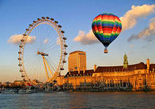

Geography of Great Britain
Pre-reading task
Answer the questions
1. What is the official name of the UK?
2. What countries does the UK consist of?
3. Have you ever been to the UK?
4. What is the capital of the UK?
5. What are the largest cities in the UK?
Great Britain (official name – the United Kingdom of Great Britain and
Northern Ireland) occupies the territory of the British Isles. They are separated by
the Irish Sea. The larger island, called Great Britain, includes 3 countries: England,
Scotland and Wales. Their capitals are London, Edinburgh and Cardiff,
respectively. The smaller island, called Ireland, includes Northern Ireland as a part
of the UK and the independent Irish Republic. The capitals are Belfast and Dublin.
In addition to these two islands, the British Isles include over five hundred small
islands.
The UK is situated off the northwest coast of Europe between the Atlantic ocean in the north and northwest, and the North Sea in the East and is separated from the European continent by the
English Channel (or La Manche) and the Strait of Dover (or Pas de Calais).
Northern Ireland is separated from Great Britain by the North Channel. The St.
George’s Channel separates Great Britain from Ireland.
Geographically, the island of Great Britain is subdivided into two main
regions - Lowland Britain (in the south and east) and Highland Britain (in the north
and west.
The mountains in Great Britain are not very high; the highest is Ben Nevis,
1,343 m, in Scotland.
There are no very long rivers in Great Britain. The longest river in Great
Britain is the Severn, flowing along the border between England and Wales. Its
tributaries include the Avon, made famous by Shakespeare; the Thames, the
deepest one, which flows eastward to the port of London through rich agricultural
districts into the North Sea. It’s the busiest and the most important river in
England.
Due to the moderating influence of the sea and the Gulf Stream, Great
Britain has an insular climate rather humid, cool, temperate and mild, without
striking differences between seasons. This humid and mild climate is good for
plants. The trees and flowers begin to blossom early in spring.
The southwest winds carry the warmth and moisture into Britain.
The British climate has 3 main features: it is mild, humid and changeable. It
is never too hot or too cold.
The weather is so changeable that the English often say that they have no
climate but only weather.
Rainfall is more or less even throughout the year. The driest period is from
March to June and the wettest months are from October to January. The average
range of temperature (from winter to summer) is from 15-23 degrees above zero.
Winter temperatures below 10 degrees are rare. Winters are extremely mild. There
may be snow but it melts quickly. January and February are usually the coldest
months, July and August the warmest. Still the wind may bring winter cold in
spring or summer days. Sometimes it brings the whirlwinds or hurricanes.
Droughts are rare.
The population of the UK is over 57 mln people. About 80% live in towns
and cities and their suburbs. Over 46 mln people live in England, over 3 mln in Wales, a little over 5 mln in Scotland and about 1,5 mln in Northern Ireland.
The UK is one of the most densely populated countries in the world: about
220 people per square kilometer. The greater part of the population lives in Greater
London, the South and the Southeast.
The UK is inhabited by the English, the Scots, the Welsh and the Irish who
constitute the British nation. The British are the descendants of different peoples
who settled in the British Isles at different times.
English is the official language of the UK. Besides standard literary English
there are several regional and social dialects. A well-known example is the
cockney of East Londoners. The Scottish and Irish forms of Gaelic survive in some
parts of Scotland and Northern Ireland. Wales is officially bilingual. Welsh
formally has the same status as English.

Comprehension check
1 Answer the following questions:
1. Where is the UK situated?
2. What two islands does the UK consist of?
3. What seas, oceans, straits and channels is the UK surrounded by?
4. What is the busiest river in the UK?
5. The Severn is the longest river in Great Britain, isn’t it?
6. What is the highest mountain in Great Britain?
7. What is the most characteristic feature of the weather in Britain?
8. Is the UK one of the most densely populated countries in the world? What
is the density of the population in the UK?
2 Are the sentences true or false?
1. The UK consists of 3 countries.
2. The UK is separated from the continent by the Irish Sea.
3. England has the highest mountains in the world.
4. The climate of the UK has rather striking differences between seasons.
7. The population in the UK mostly lives in Scotland.
3. Vocabulary
Give English equivalents of the following words and word combinations:
занимать территорию, состоять из, быть в двa раза меньше, быть отделенным
от, на 40 км южнее от…, самая загруженная и важная река, мягкое
(умеренное) влияние, резкое различие, изменчивая погода, средний уровень
температуры, плотность населения
4. Complete the following sentences:
1. Great Britain occupies the territory of …
2. They are separated by…
3. The larger island, called…
4. In the northwest and west the country is surrounded by…
5. Ireland is separated from Great Britain by…
6. The mountains in Great Britain…
7. The British climate has …
8. The UK is inhabited…

The British Monarchy Today
The United Kingdom is a constitutional monarchy. This means that it has a monarch (a king or a queen) as its Head of State. The monarch reigns with the support of Parliament. The powers of the monarch are not defined precisely. Everything today is done in the Queen’s name. It is her government, her armed forces, her law courts and so on. She appoints all the Ministers, including the Prime Minister. Everything is done, however, on the advice of the elected Government, and the monarch takes no part in the decision-making process.
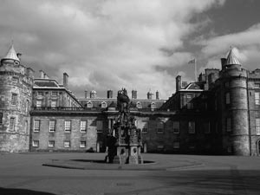
Palace of Holyroodhouse, Edinburgh
Once the British Empire included a large number of countries all over the world ruled by Britain. The process of decolonisation began in 1947 with the independence of India, Pakistan and Ceylon. Now there is no longer an empire. But the British ruling classes tried not to lose influence over the former colonies of the British Empire. An association of former members of the British Empire and Britain was founded in 1949. It is called the Commonwealth. It includes many countries such as Ireland, Myanma, the Sudan, Canada, Australia, New Zealand and others. The Queen of Great Britain is also the Head of the Commonwealth, and so the Queen of Canada, Australia, New Zealand...
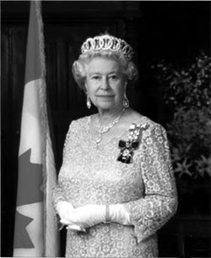
Her Majesty the Queen Elizabeth II
The Queen is very rich as are other members of the royal family. In addition, the government pays for her expenses as Head of State, for a royal yacht, train and aircraft as well as for the upkeep of several palaces. The Queen’s image appears on stamps, notes and coins.
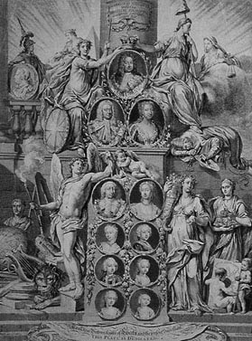
Parliament consists of two chambers known as the House of Commons and the House of Lords. Parliament and the monarch have different roles in the governing of the country, and they only meet together on symbolic occasions such as the Coronation of a new monarch or the Opening of Parliament. In reality, the House of Commons is the only one of the three which has true power. It is here that new bills are introduced and debated. If the majority of the members are in favour of a bill it goes to the House of Lords to be debated and finally to the monarch to be signed. Only then does it become law. Although a bill must be supported by all three bodies, the House of Lords only has limited powers, and the monarch has not refused to sign one since the modern political system began over 200 years ago.
REFERENCES
the Commonwealth Содружество (политическое и экономическое объединение, центром которого является Великобритания. Включает 54 независимых государства. В Содружество входят также зависимые территории Великобритании, Австралии и Новой Зеландии)
chamber палата парламента
the House of Commons палата общин (нижняя палата парламента; играет главную роль в осуществлении его законодательных функции)

the House of Lords палата лордов (верхняя палата парламента; невыборное учреждение; участвует в осуществлении законодательных функций парламента; является высшей апелляционной инстанцией)
bill билль, законопроект
I. COMPREHENSION
Are the following statements true or false, according to the text? (T/F)
1. The monarch takes an active part in the government’s decision-making process.
2. Canada, Australia and New Zealand are constitutional monarchies and the Queen of Great Britain is the head of these states.
3. India, Pakistan and Ceylon are former members of the British Empire.
4. The powers of the monarch, the House of Commons and the House of Lords are defined precisely.
5. Her majesty Queen Elisabeth II appoints all the Ministers except the Prime Minister.
6. Parliament and the monarch meet once a month.
II. VOCABULARY
Match these words from the texts to their meanings.
1. to reign
2. precisely
3. to appoint
4. expenses
5. to define
6. the majority
7. to sign
8. to be in favour of
9. to refuse
10. royal
a) exactly, clearly
b) relating to a queen or king or the members of their family
c) to rule officially a country (about a king or queen)
d) to not give someone what they ask, or not let someone do what they ask to do
e) to support an idea
f) to write your name on something in your own personal way
g) most of the people or things in a group
h) to choose someone to do a job or have a position
i) to describe cleary and exactly what something is
j) money you spend as part of your job that your employer later gives back to you
III. GRAMMAR PRACTICE
A. Find sentences with the verbs in the Passive forms and translate them into Russian.
B. Make the necessary changes to transform these sentences from the Active into Passive:
1. No one can define the powers of the monarch precisely.
2. The Government does everything in the Queen’s name.
3. They formed an association of former members of the British Empire.
4. The Queen signs a bill.
5. The Government pays for the Queen’s expenses as Head of State.
6. The Queen appoints the Prime Minister.
IV. COMMUNICATION PRACTICE
A. Discuss this question in pairs:
What does the term “a constitutional monarchy” mean?
B. Summarise the text by answering these questions. You should talk for 1 to 2 minutes.
1. Which are the powers of the monarch?
2. How did the British Empire change after 1947?
3. Who pays for the queen’s expenses as Head of State?
4. Which of the three bodies (the monarch, the House of Commons and the House of Lords) has true power?
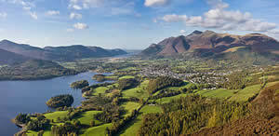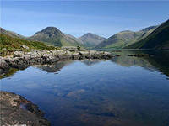
The Lake District
The Lake District is a ___1___ area in the north-west of England? And it has some of England’s ___2___ scenery. Some admiring ___3___ called it “A paradise of mountain scenery and magical life”. ___4___ lakes lie in deep hollows dug out by the glacier which covered Britain during the Ice Age. Green hills, herds of ___5___, and solitary farms scattered here and there are typical of this remote and ___6___beautiful part of England.
The Lake District is a ___7___ Park, which means that special care is taken to make sure that the beauty of the countryside is not spoiled. The people who are responsible for preserving the Lake District’s natural beauty are members of the National Trust.
The National Trust is a public ___8___ which is financed by ordinary people who pay to become members. The Trust was set up in 1895 by three people who thought that industrialization could spoil the countryside and ancient buildings of England and Wales. The National Trust members keep an eye on ___9___ gardens, whole villages, lakes and hills, abbeys, ___10___ and Roman antiquities.
- mountain
- beautiful
- visit
- picture
- sheep
- surprise
- nation
- organize
- fame
- history
SPEAKING
Your friend is going to spend holidays in the Lake District. Would you like to join? Why?

